Environmental Issues in Sports Medicine Project: Sports Medicine 1
Students will work in groups of 7 to complete the following assignment.
Each group is responsible to complete:
*A 10 question quiz to give to the class at the end of your presentation
*A website presentation of the causes, signs/symptoms, treatments, and prevention of each condition.
*Handouts for the students that summarize the causes, signs/symptoms, treatments, and preventions of each condition. This is to help the students follow the website presentation.
*A Pecha Kucha video presentation about a real life example of a person who survived one of your group’s conditions. See the following description of Pecha Kucha:
*PK is a simple presentation format where the presenters show 20 slides, each for 20 seconds (6:40 total). The images advance automatically and the presenters talk along to the slides. This forces the presenters to be concise in demonstrating their ideas.
*Each slide is visual-you may have a word or phrase on some of your slides, but no complete sentences.
*You will have to be well-planned in order to present your PK – it is advised that you script out and rehearse what you plan to say over your slides.
*It is helpful to view examples of PK’s online.
-------------------------------------------------------------------------
Groups will “battle it out” for points. The group with the most points wins.
***10 Question quiz; 10 points
***Website design: 30 points
***Website Handouts: 10 points
***website presentation: 10 points
***Pecha Kucha: 40 points

Team Johnny Storm/Firestar: Hyperthermia, Heat Stroke, Heat Exhaustion, Burns, Etc…
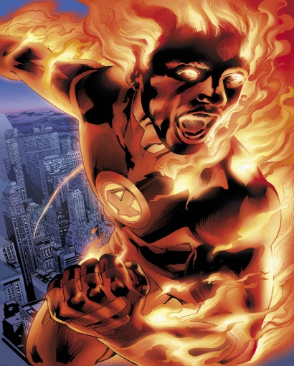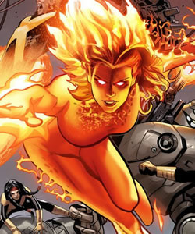
Team Ice/Ice Man: Hypothermia, Frostbite

Team Spiderman/Wasp: Animal and Insect Bites and stings, Allergies, etc…
Team Storm/Shazam: Lightning and Tornadoes

Think you are a Superman or Wonder Woman and you can do this on your own? One student can break off from their group (with a partner if needed) and do the project on their own.

