How did he do it? Mike Wardian on breaking record for seven marathons in seven days
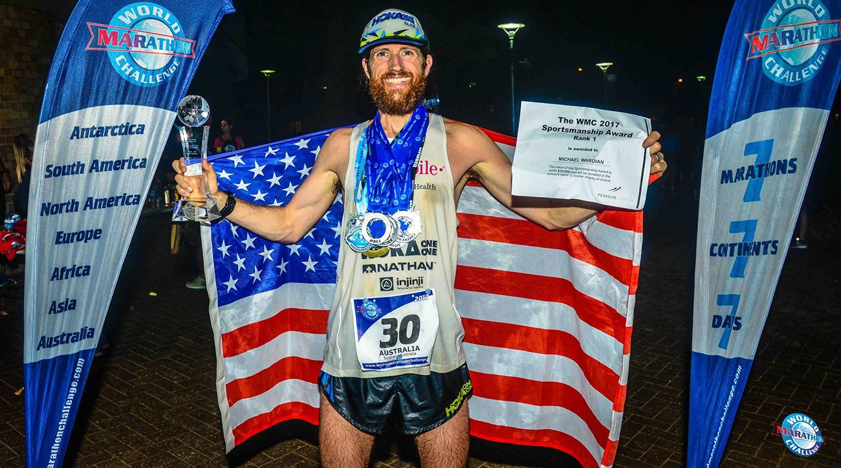

QUICKLY
- After breaking the World Marathon Challenge record for seven marathons in seven days on seven continents, Michael Wardian sits down to talk diet, recovery, mentality and more.
SHARE

CHRIS CHAVEZ
Tuesday January 31st, 2017
Even after winning seven marathons in seven days on seven continents, Mike Wardian wasn’t finished running. He laced up his shoes and added another 16 miles just to hit 200 miles for the week.
Wardian, 42, averaged 2:45:56 for the seven races, which shattered the previous World Marathon Challenge record. The series started on January 23 with -20 degree conditions in Antarctica (2:54:54) before warming up in Chile (2:45:42), heading back to home soil in Miami, Fla. (2:37:56), touching Madrid, Spain (2:42:35), continuing east to Marrakech, Morrocco, (2:49:25) and Dubai (2:45:33) and finally concluding in Sydney, Australia (2:45:31).

“I thought it was going to be easier but I quickly learned it was going to take a yeoman’s effort,” Wardian says. “I had done the training but I was unsure of the other factors that would be thrown at me and what I love about these races is learning how to adapt and overcome them.”
Wardian was the top finisher in a field of 32 men and women that also included Olympian Ryan Hall, who once ran 2:04:58 at the Boston Marathon. Hall averaged 3:39:36 for his seven races, which includes a 3:04:56.
SI caught up with Wardian over the phone as he departed Australia. The following interview has been edited for space and clarity.
Chris Chavez: Why would someone in his or her right mind do something like this?
Mike Wardian: I’ve wanted to do this since I heard about it while running the North Pole Marathon a few years ago. I didn’t think it was possible. It took me three years to get the time and resources to make it happen but it’s been on my radar for some time. This is something that I’m suited for because I love to race. I love to do stage races, back-to-back marathons and ultramarathons so this was something I thought I could do very well in. It was also going to be a logistical challenge from sleep, group dynamics, travel and just the mileage. Those factors also drew me to it. It captures your imagination when you line up the symmetry of seven marathons, seven days and seven continents.
CC: Where does this rank among other races that you’ve done?
MW: I’d say it’s in the top three. I did Marathon des Sables (a six-day, 156-mile ultramarathon) where I had to carry all my food and gear across the Sahara Desert. That one is extremely challenging. I also did Diagonale Des Fous with tendonitis in my foot and it has more than 9,000 meters of ascent and descent. I couldn’t miss it but I was in a world of hurt.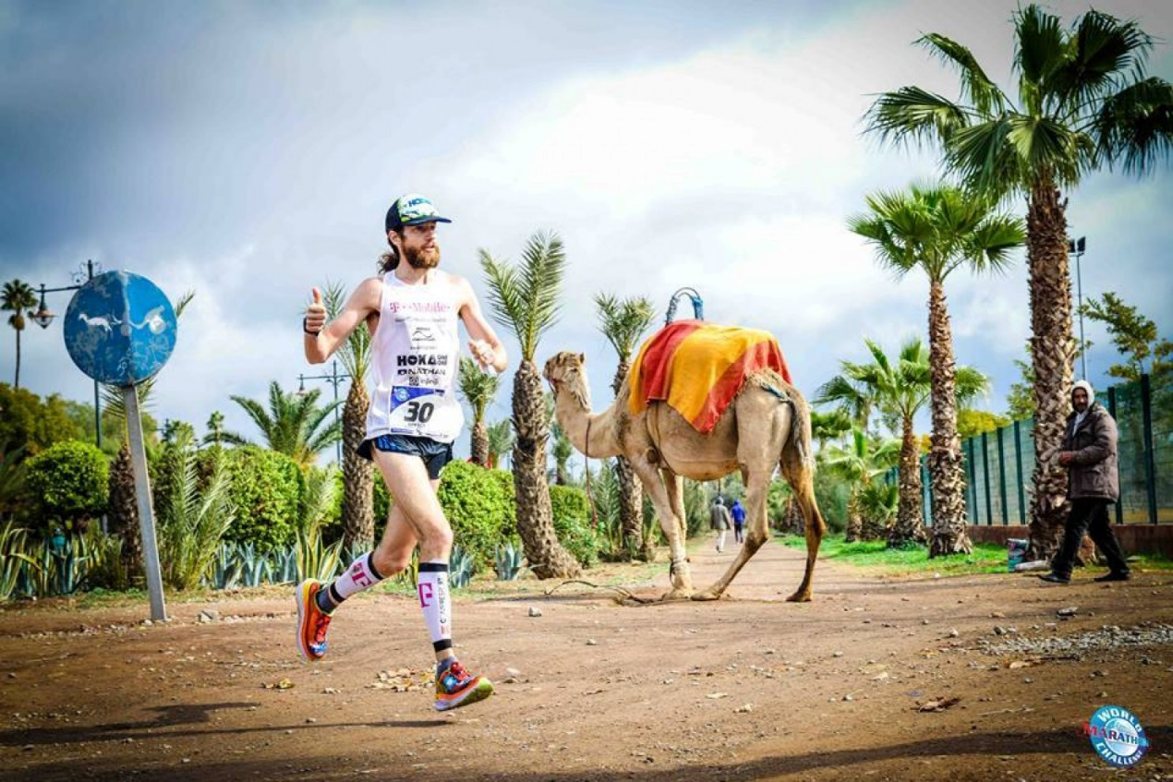
Courtesy of World Marathon Challenge
​
CC: What were the biggest challenges with travel and how much sleep did you get between marathon legs?
MW: I did not sleep very much. I typically don’t sleep very much. If I can get four or six hours that’s incredibly good. I’d say in the first four days, I slept a total of eight hours. After that, I slept four hours in Morocco and then we went to Dubai. I slept zero hours on the way there. I kept telling myself that I needed to but I just couldn’t. I tried emails and meditation but nothing worked. From Dubai to Australia via Jakarta so we were on a plane for maybe 15 hours and I think I slept about six more. That’s why when it finished, I was a zombie. I slept six hours last night and I feel like someone fired me up with rocket juice. I’m perfectly fine.
CC: Why wouldn’t you take melatonin to help you fall asleep?
MW: I don’t do it for a number of reasons and being an athlete, I’m a big believer in clean sport. I didn’t take anything. Not Advil, not Sudafed or cough drops because I don’t want to risk any chance that I trigger a drug test. For me that’s part of the challenge too and I don’t want to artificially impact that.
CC: You are a vegetarian and you were running on whatever you ate for fuel. What was your calorie intake like between races?
MW: I also don’t eat dairy anymore and usually the first thing that people go for is cheese if they don’t eat meat. I had a ton of almond butter. I had a bunch of oatmeal packets and some olives. During the races, I lived on gels, salt tablets, Succeed (electrolyte supplements), water, some Gatorade and Coca-Cola. I basically treated it like an ultramarathon.
I usually eat a lot of fresh fruit and vegetables. I was super careful about that and that was frustrating. Plane food wasn’t interesting to me but I was so hungry that I had to eat nuts out of my bag and raisins. My wife made homemade granola and these almond coconut balls from one of my sponsors that makes artisanal nut butters.
It was all business and I was eating for performance. I was very careful because I’d gotten sick before a race before.
The funny story came from my last meal. They put a plate of pad thai and green curry in front of me and I was thinking, “No! What are you doing to me?” That’s one of my favorite dishes in the world. I put it away for 25 minutes and I ate oatmeal but I was still hungry so I took it back out and ate it all in like three seconds. I knew that was the wrong choice but with human nature sometimes you can’t stop yourself.
CC: The slowest of your seven marathons was a 2:54:54 in Antarctica, but that’s even not slow to the average runner. Was that the toughest course and how did you get through those cold conditions?
MW: I had never run in Antarctica before so I was more than happy to run six other marathons if it meant I could run one there. It was a dream come true. It was one of the most beautiful places that I have ever run. It was also the first day, so I was just trying to bring it to everyone else and establish myself with a good time. I was feeling fit but didn’t know how fast I could go. In the end, I think I ended up setting a continental record. It was pretty impressive and I think it made everyone else run faster. A few people managed to get under the old course record.
I tried to have Ryan Hall pace me but he turned to me and said, “I can’t keep up, man. Good luck.” That was cool because I’ve run against him before and he’s such a badass. I was able to feed off the energy of everyone.
I told my wife that now I want to do a transit of the whole continent, which could be really awesome. I don’t like the cold but to be able to run that well and overcome those fears was empowering and set the stage of what came after.
CC: What other major races or running goals are left on your bucket list? Word is that you’re doing the Barkley’s Marathon, a mysterious 100-mile ultramarathon trail race held in Frozen Head State Park near Wartburg, Tenn.
MW: Yes. I got into that and I also have been putting my name into consideration for the Hardrock Hundred Miler in Silverton, Colo., for the past six years, so I finally got into that. I’m also doing the Western States 100 in Squaw Valley, Calif. and I’ll do the Ultra-Trail Australia.
There’s so many races on my bucket list. I was talking about it with some guys in the way to the airport. I’d love to run a marathon or an ultramarathon on the moon. I have crazy aspirations. I want to run across the Panama Canal or the Pilgrim’s Trail. There’s so many great races out there and if anyone knows of a good race, I’m all up for racing on roads, trails, treadmills and everything.
CC: 200 miles in a week is the most you’ve ever done. How many miles did you finish the year in 2016 with?
MW: Last year, I think I finished with about 4,000 or 5,000 miles and just in races about 1,400 miles. I’m hoping to do even more this year. You try to improve every year. Last year, I would do 50 push-ups every day and now I’m doing 60. Keep improving and growing as a person is what it’s all about. I hope that’s what inspires people.
CC: Would you do this again? It’s been barely 24 hours since you finished so I feel like I’m asking so soon.
MW: I already said I would love to do it again. There’s definitely ways I can do better and there’s some things I can fix knowing what I know now.
CC: How many times does someone hit you with a ‘Run, Forrest, Run’ on a run? You’re a real life Forrest Gump.
MW: It’s not unique! I hear ‘That’s Forest Gump!’ and I just cheer along with them. It’s all fun to me.

How do you recover after seven marathons in seven days?
Wardian will return home to Arlington, Va., for a few days before his family before the Tarawera 100K ultramarathon race next weekend. Below, he shares his top tips for recovery.​
Foam Rolling
“I love foam rolling and I personally use an Addaday foam roller. If you can’t get a massage this is the next best thing. It just loosens your legs up and gives you the ability to get back out there. Quick and convenient.”
Stretching
“I’m not a huge stretcher but I try to do it and find it useful when I call people. When I’m on the phone, I’m pulling my legs up, touching my toes or spread my legs.”
Keep moving
“So many people get trapped after a race. It’s not the time to put your feet in a bucket of ice. Keep moving. It’s one of the best things that you can do.”
Replenish drinks and fluids
“Consume copious amounts of liquid after a race. I’m more of a fresh fruit guy. Get some good calories in and treat yourself when your body craves it.”
Sleep
“If you can get it, that’s great. Sometimes we’re conditioned to think that we need it but your body is an amazing thing. If you don’t get it, don’t sabotage yourself or let your mind override that.”
Wardian's sample diet for a day
During the World Marathon Challenge on his way from Morrocco to Dubai, Wardian shares his food diary from that day.
Food after marathon:
2 fresh orange juices
1 small olive baguette
1 couscous with veggies
6 Jennifer's almond butter and coconut balls
Water, lots of water
Dinner: fruit, on plane
Breakfast: 1 GU waffle
During race: GU, electrolyte caps and water and coke.

