Warm-Ups, Cool-Downs, What Works, What Doesn’t
Phys Ed
By GRETCHEN REYNOLDS MARCH 8, 2017
Continue reading the main story
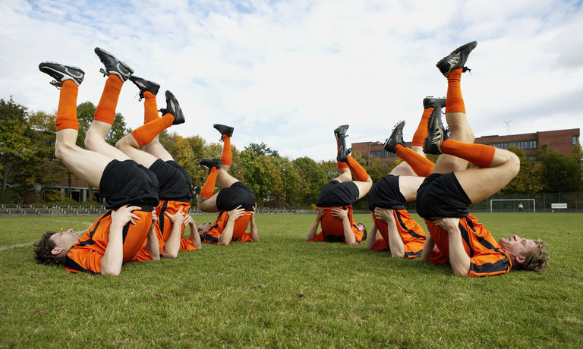

Athletes could be increasing their risk for sports injuries or simply wasting their time by practicing certain types of warm-ups and cool-downs, according to two practical new studies. Together, the new research indicates that a rigorous warm-up could keep you running smoothly during a sports season, whereas a popular cool-down technique, the ice bath, is likely only to leave you cold.
Anyone who plays sports or otherwise exercises has almost invariably heard that we should warm up before every training session and competition, and cool down after.
The warm-up is meant to ready us for the physical exertions to follow, allowing us to perform better and, in theory, not hurt ourselves.
The cool-down, on the other hand, is supposed to soothe tired muscles, easing some of the damage caused during training and preparing our bodies to return to exercise in the days ahead.

But there has been little scientific or anecdotal consensus about the ideal ways to warm up or cool down.
So for the first of the new studies, which was published in January in the British Journal of Sports Medicine and is being presented next week at the IOC World Conference on sports-injury prevention in Monaco, scientists from the University of Copenhagen and other institutions decided to systematically examine the effects of some of the world’s best-known warm-up programs, the FIFA 11 and its recent update, the FIFA 11+.
Designed by sports scientists affiliated with FIFA, the original FIFA 11 warm-up is light and quick, lasting about 10 minutes and involving various kinds of jumping, shuffling and balancing exercises.
The updated FIFA 11+ is more intense, requiring repeated sprints and exercises such as squats, leg lifts and vertical leaps.
While many experiments have tested whether these warm-ups keep athletes healthy, most have been small and their results inconclusive. But the new study systematically pooled data from the best earlier studies, those that randomly assigned athletes to warm up either with a FIFA program or some other routine (usually stretching and jogging) and then tracked injury rates for at least a season.
By combining the results, the researchers wound up with information about almost 4,000 male and female recreational soccer players, ranging in age from adolescents to middle-aged adults.
And the outcomes were striking. Those boys, girls, men and women who regularly completed the FIFA 11+ warm-up before training or games were about 40 percent less likely to sustain knee, ankle, hamstring, and hip or groin injuries during the season than athletes who warmed up in other ways.
Interestingly, the easier FIFA 11 warm-up did not substantially reduce the incidence of subsequent injuries.
“The FIFA 11+ presumably reduces injuries by improving muscle strength, balance and coordination,” while the older version and most other warm-up routines do not, says Kristian Thorborg, an associate professor of sports and musculoskeletal physiotherapy at the University of Copenhagen and the study’s lead author.
He adds that the FIFA 11+ warm-up is likely to be effective at reducing injuries not only among soccer players but also those in basketball and other sports “that include sprinting, cutting and rapid changes in acceleration.”
But it is an energetic and intricate program that should be begun slowly at the start of a sports season, he says. (The FIFA 11+ website details three different levels of the warm-up, so that athletes can progressively ramp up its intensity.)
At the conclusion of their workout, though, athletes may wish to skip one of the more common approaches to cooling down, the ice bath, according to the other new study, which appeared last month in the Journal of Physiology.
Slipping into a bathtub filled with frigid water after a hard workout has long been routine for many athletes, who have believed that the chilly temperatures will reduce inflammation in their tired muscles and help their bodies to physiologically recover more quickly from strenuous exercise.
But the new study finds otherwise. In it, scientists from Queensland University of Technology in Australia and other schools asked a group of healthy young men to twice complete a grueling lower-body weight workout, using only one leg. After one of these sessions, the men eased themselves into a bathtub filled with water cooled to 50 degrees Fahrenheit (10 degrees Celsius) and lay there for 10 minutes. On the other day, they slowly pedaled an exercise bike, also for 10 minutes, a light activity that mimics how athletes who do not choose to flash-freeze their limbs might cool down.
During each session, the scientists took tiny samples of blood and muscle tissue from the athletes before and soon after their cool-downs and again 24 and 48 hours later and microscopically examined them for evidence of inflammation and changes in the activity of certain genes that can contribute to muscle soreness.
If the cold bath were working as athletes hoped, the scientists reasoned, there would be fewer markers of inflammation and potential soreness in their working muscles after the bath than after the gentle pedaling.
But there were not. The number of cells associated with inflammation was much higher in the men’s exercised legs compared to their unused legs after each workout. But those numbers were not significantly lower after the chilly bath than after the pedaling, either immediately or two days later, says Jonathan Peake, a lecturer at Queensland University of Technology who led the study.
The scientists did not ask the men how their legs felt or objectively measure whether they could return to strenuous exercise sooner after the ice baths.
But the cellular evidence suggests that a cold bath may do little for heavily exercised muscles except chill them.

